ONEWAY Memory BY WOKE
/STATISTICS DESCRIPTIVES HOMOGENEITY WELCH
/PLOT MEANS
/MISSING ANALYSIS.

Oneway

Notes
Output Created |  | 05-May-2019 23:48:57
Comments
Input | Active Dataset | DataSet0
Input | Filter | <none>
Input | Weight | <none>
Input | Split File | <none>
Input | N of Rows in Working Data File | 30
Missing Value Handling | Definition of Missing | User-defined missing values are treated as missing.
Missing Value Handling | Cases Used | Statistics for each analysis are based on cases with no missing data for any variable in the analysis.
Syntax |  | ONEWAY Memory BY WOKE  /STATISTICS DESCRIPTIVES HOMOGENEITY WELCH  /PLOT MEANS  /MISSING ANALYSIS.
Resources | Processor Time | 00 00:00:00.172
Resources | Elapsed Time | 00 00:00:00.199

[DataSet0]

Descriptives
 | N | Mean | Std. Deviation | Std. Error
Between 1-4 hours | 5 | 88.4500 | 28.26183 | 12.63908
Between 4-6 hours | 9 | 86.7778 | 39.94282 | 13.31427
Between than 6-8 hours | 3 | 90.9633 | 38.36690 | 22.15114
More than 8 hours | 13 | 102.7654 | 32.04357 | 8.88729
Total | 30 | 94.4030 | 33.66618 | 6.14658

Descriptives
 | 95% Confidence Interval for Mean |  | Minimum | Maximum
 | Lower Bound | Upper Bound | Minimum | Maximum
Between 1-4 hours | 53.3583 | 123.5417 | 67.50 | 138.00
Between 4-6 hours | 56.0750 | 117.4805 | 48.00 | 166.00
Between than 6-8 hours | -4.3453 | 186.2720 | 64.75 | 135.00
More than 8 hours | 83.4016 | 122.1291 | 60.75 | 162.00
Total | 81.8318 | 106.9742 | 48.00 | 166.00

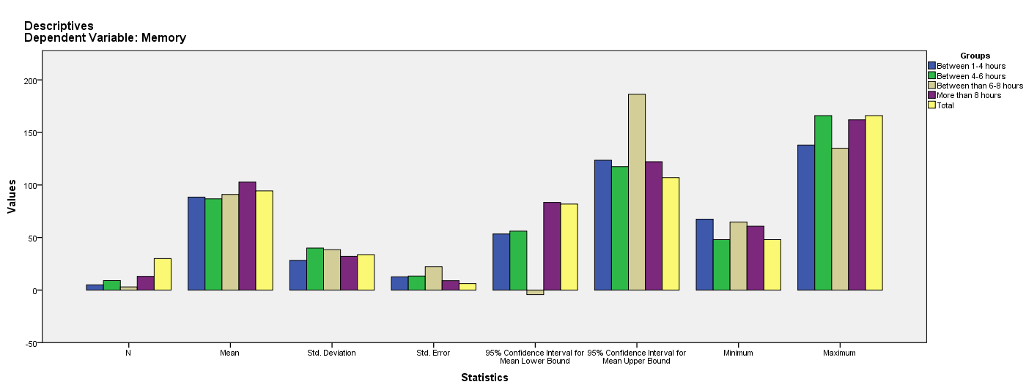

Test of Homogeneity of Variances
Memory
Levene Statistic | df1 | df2 | Sig.
.341 | 3 | 26 | .796

ANOVA
Memory
 | Sum of Squares | df | Mean Square | F | Sig.
Between Groups | 1645.064 | 3 | 548.355 | .457 | .715
Within Groups | 31223.881 | 26 | 1200.918
Total | 32868.945 | 29

Robust Tests of Equality of Means
Memory
 | Statisticª | df1 | df2 | Sig.
Welch | .409 | 3 | 7.430 | .751
a. Asymptotically F distributed.

Means Plots

